Southeastern Cave Conservancy (SCCi)

Permanent Fixed Rope Management Plan

Purpose
The purpose of this document is to detail the location, description, and reasoning behind the installation of permanent fixed rope(s) and corresponding hardware in caves on SCCi preserves. Since they are to remain in the cave for perpetuity, potential hazards that would affect their physical condition and safe use in perpetuity must be identified and mitigated when possible. A robust periodic inspection plan shall assess their physical condition, and results will be documented. Special attention shall be given to areas where hazard(s) cannot be mitigated. Should a concern about the physical condition of a fixed rope and/or hardware be identified during inspection or from a preserve visitor report, this document will detail repair and/or replacement methods for any foreseeable situations. All ropes and hardware will be replaced periodically no later than the stated service life of their respective manufacturer.

Inspection Checklist
- Inspect entire rope length for sheath abrasion or damage
- Inspect knots to ensure they are proper and secure
- Verify screwlinks are screwed closed and tight; tighten if loose, replace if open
- Verify bolts and bolt hangers are not loose; tighten if loose. If rock decay is the reason, bolt replacement in new location is required
- Inspect all hardware for corrosion
- If present, inspect webbing for abrasion and damage, and verify knots are secure and proper

Potential Hazards List (non-exhaustive)
Rock/rope abrasion Age
Waterfall/rope abrasion Dynamic fall from user
Abrasion from use Cave animals
Rock fall Chemical exposure
Moisture corrosion Rock decay
Galvanic corrosion

Overview

CAVE NAME: Gourdneck Cave
PRESERVE: Gourdneck Cave Preserve

 | Location | Description | # of bolts | # of ropes | Height | Install Date | Inspection frequency
1 | Axel Falls bypass | Rope climb to top of canyon | 4 | 2 | 35’ | 8/21/19 | 1 year
2 | Hans Falls | Rope climb up waterfall drop | 2 | 1 | 27’ | 12/3/17 | 1 year
3 | Halfway House Dome | Rope to high point of aid climb in dome | 2 | 1 | 177’ | 10/25/19 | 5 years
4 | Mt. Stromboli Dome | Rebelayed rope climb to top of dome | 8 | 1 or 2 | 191’ | 7/14/19 | 3 years
5 | Mt. Stromboli Dome | Traverse line from south to east passage | 5 | 1 or 2 | N/A | 8/22/19 | 3 years

Location 1 – Axel Falls bypass

Description: 35’ rope climb anchored from two ceiling bolts, connected to a 2-bolt traverse line over the canyon to the next passage. The vertical line and traverse line share two bolts.

Rationale: This rope was installed at what used to be a difficult and very exposed 35’ free climb up in a canyon. While the climbup can still be done, having this permanent rope in place strongly encourages visitors to climb the rope instead of attempt the free climb, a much safer option. This expectation is reasonable because visitors should already have vertical gear due to the entrance pit. At least one fall with a self-rescue injury has occurred here since SCCi began leasing the cave in 1998 before the rope was placed. A natural anchor is available, but it causes rope rub hazards which are better mitigated by using bolted anchors placed where there are no rope rubs.

Rigging Diagram
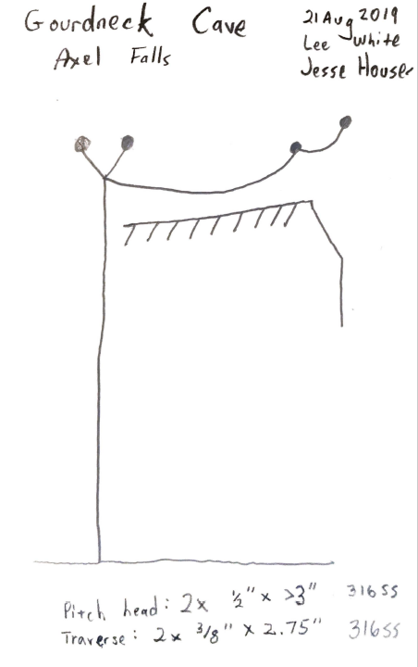

Hardware Specifications
- Two ceiling bolts: ½” x 3” 316 SS wedge bolts
- Two traverse line bolts: 3/8” x 2 ¾” 316 SS wedge bolts

Rope Specifications
- Up rope: 11mm nylon static kernmantle, approx. 45’ long, unknown manufacturer
- Traverse rope: 11mm nylon static kernmantle, approx. 25’ long, unknown manufacturer

Hazards Identification
Hazard | Identified? | Notes/mitigation efforts
Rock/rope abrasion | No | Bolts placement keeps rope off rock
Waterfall/rope abrasion | No | No waterfalls close enough to abrade rope, but waterfall mist does keep this area wet always
Abrasion from use | Yes | High traffic area, heavy wear from use expected
Rock fall | No | No loose rock overhead of rope or bolts
Moisture corrosion | Yes | All bolts are corrosion resistant 316 stainless steel. Nylon ropes lose about 15% of rated strength when wet, but are still within safe working load (SWL).
Galvanic corrosion | No | Only stainless steel hardware used.
Age | Yes | Indefinite lifetime on hardware. 10 year maximum lifetime on nylon ropes per most manufacturers
Dynamic fall from user | Yes | Static ropes can be damaged from dynamic falls. Traverse line would experience this if a visitor fell while attached to it
Cave animals | No | Rope location is not reachable by animals known to chew on ropes, like pack rats or mice
Chemical exposure | No | No chemical exposures expected
Rock Decay | No | Good rock quality, issues not expected

Inspection Interval: 1 year
Due to its location in a high traffic area, abrasion from use is expected to be high, so this fixed rope should be inspected at least annually, or anytime upon receiving any report of damage from a preserve visitor.

Repair/Replacement Considerations
Should any part of this fixed rope system need to be repaired or replaced, it can be accessed via the free climb up in the same location.

Location 2 – Hans Falls

Description: 27’ waterfall climb anchored from two ceiling bolts. The small crawlway passage at the top necessitated the placement of the bolts in the ceiling to safely get on/off rope, but this causes the rope to hang in the waterfall during use.

Rationale: This waterfall cannot be free climbed, so the up rope here is essential to allowing access to the upper half of the cave.

Rigging Diagram
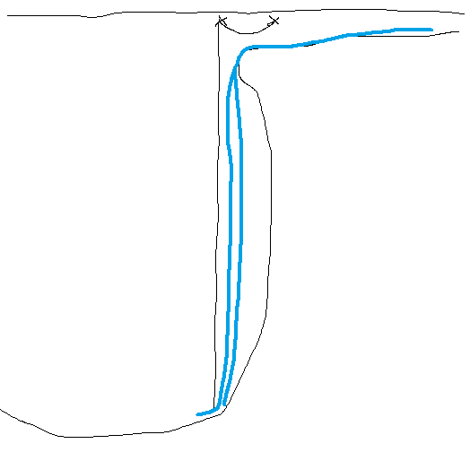

Hardware Specifications
- Two ceiling bolts: 3/8” x 2 ¾” 316 SS wedge bolts

Rope Specifications
- 11mm nylon static kernmantle, approx.. 75’ long, unknown manufacturer

Hazards Identification
Hazard | Identified? | Notes/mitigation efforts
Rock/rope abrasion | No | Bolts placement keeps rope off rock
Waterfall/rope abrasion | Yes, significant hazard | Hans Falls is a major waterfall, and the rope will be destroyed if left to hang in the waterfall. The rope tail must be pulled clear and tied off to keep the rope out of the waterfall when not in use
Abrasion from use | Yes | Moderate traffic area, some wear from use expected
Rock fall | Yes | No loose rock overhead of bolts. However, cobbles can roll out of crawlway during flood events and potentially damage the rope
Moisture corrosion | Yes | All bolts are corrosion resistant 316 stainless steel. Nylon ropes lose about 15% of rated strength when wet, but are still within safe working load (SWL).
Galvanic corrosion | No | Only stainless steel hardware used.
Age | Yes | Indefinite lifetime on hardware. 10 year maximum lifetime on nylon ropes per most manufacturers
Dynamic fall from user | Yes | Static ropes can be damaged from dynamic falls. Since it is inherently difficult to get on/off rope from a crawlway, this hazard is more likely than average
Cave animals | No | Rope location is not reachable by animals known to chew on ropes, like pack rats or mice
Chemical exposure | Unlikely | No chemical exposures expected, unless chemical pollution is washed into the cave
Rock Decay | Yes | Waterfall lip is shale, a chunk could break off at any time and damage the rope below

Inspection Interval: 1 year
Due to its location at a major waterfall, water abrasion is a constant hazard. The rope can be damaged by the waterfall should a preserve visitor neglect to tie back the rope tail, or from a particularly severe flood. Thus, this fixed rope should be inspected at least annually, or anytime upon receiving any report of damage from a preserve visitor, or after a severe flood event.

Repair/Replacement Considerations
Should any part of this fixed rope system need to be repaired or replaced, it can only be accessed from below. If the fixed rope system is deemed unsafe to use upon an initial inspection from the bottom, then the only way to safely approach the bolts would be via an aid climb. In lieu of this, the rope should be tied back or cut in some manner as to make it unusable for visitors.

Location 3- Halfway House Dome

Description: Rope rigged from high point of 177’ bolt climb up the 200’ tall Halfway House Dome. Rope is anchored to two bolts in the wall of the dome, no ledge at the anchors and no passages accessible from the top of the rope. Rope is free hang to the floor but is close to the wall.

Rationale: While the rope currently does not access any new passages, there is a 4’ high passage visible 15’ overhead. The person originally attempting this dome climb died in 2019 before completing it. The current rationale is to leave this fixed rope in place to allow the climb to be completed by someone else in the near future, if there are any volunteers. If not, the fixed rope can be derigged at a later date.

Rigging Diagram
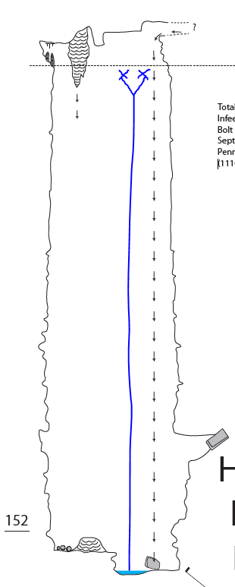

Hardware Specifications
- Two wall bolts: 3/8” x 2 ¾” 316 SS wedge bolts

Rope Specifications
- 11mm nylon static kernmantle, approx. 200’ long, unknown manufacturer

Hazards Identification
Hazard | Identified? | Notes/mitigation efforts
Rock/rope abrasion | Yes | Rope near the wall but minimal contact expected
Waterfall/rope abrasion | No | Small waterfall in dome is too far away to pose a hazard
Abrasion from use | Yes | Low traffic area, but some wear from visitor use expected
Rock fall | Yes | Potentially loose rock seen overhead
Moisture corrosion | Yes | All bolts are corrosion resistant 316 stainless steel. Nylon ropes lose about 15% of rated strength when wet, but are still within safe working load (SWL). Humid environment due to waterfall nearby
Galvanic corrosion | No | Only stainless steel hardware used.
Age | Yes | Indefinite lifetime on hardware. 10 year maximum lifetime on nylon ropes per most manufacturers
Dynamic fall from user | Yes | Static ropes can be damaged from dynamic falls.
Cave animals | No | Rope location is not reachable by animals known to chew on ropes, like pack rats or mice
Chemical exposure | No | No chemical exposures expected
Rock Decay | No | Good quality rock, issues not expected

Inspection Interval: 5 years
Low traffic is expected on this rope, and no hazards are deemed to pose a risk to the rope or anchor on a regular basis. Thus it is recommended that this fixed rope system should be inspected at least every 5 years (half the service life of the rope), or anytime upon receiving any report of damage from a preserve visitor.

Repair/Replacement Considerations
Should any part of this fixed rope system need to be repaired or replaced, it can only be accessed from below. If the fixed rope system is deemed unsafe to use upon an initial inspection from the bottom, then the only way to safely approach the bolts would be via an aid climb. In lieu of this, the rope should be tied back or cut in some manner as to make it unusable for visitors.

Location 4- Mt. Stromboli Dome (vertical line)

Description: Complex fixed rope system established via aid climb to access the top of Mt. Stromboli Dome, 220’ tall. The rope system itself is 191’ high: 3 double bolt rebelays with a J-rappel between 2 of them, and a double bolt anchor at the top. The rope is padded in 3 places between the top anchors and the first rebelay down as it passes over several muddy ledges. Top rope tail is tied to a large boulder as a backup. The rope accesses the south passage at the top of the dome, which goes to the high point of the cave a short distance away.

Rationale: While there is not a lot of passage to see at the top of the dome, what is there is impressive. The effort it took to complete the aid climb was enormous, and with a proper management plan it can be safely maintained for others to appreciate in the future.

Rigging Diagram
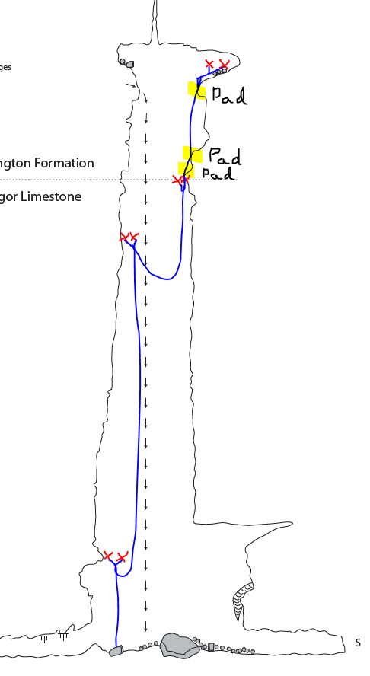

Hardware Specifications
- Eight bolts: 3/8” x 2 ¾” 316 SS wedge bolts

Rope Specifications
- 11mm nylon static kernmantle, unknown lengths, unknown manufacturer. May be two different rope sections joined at the 2nd rebelay

Hazards Identification
Hazard | Identified? | Notes/mitigation efforts
Rock/rope abrasion | Yes | Not much wall contact up to the 3rd rebelay, but there is heavy contact on the 3 rope pads on the way up to the top anchors.
Waterfall/rope abrasion | No | Small waterfall in dome is too far away to pose a hazard
Abrasion from use | Yes | Low traffic area, but some wear from visitor use expected. Improper technique on J-rappel could also cause excess wear on the rope
Rock fall | Yes, significant hazard | Lots of loose rock on ledges above top rebelay around the rope pads. Most concerning rocks were removed during rope installation
Moisture corrosion | Yes | All bolts are corrosion resistant 316 stainless steel. Nylon ropes lose about 15% of rated strength when wet, but are still within safe working load (SWL). Humid environment due to waterfall nearby
Galvanic corrosion | No | Only stainless steel hardware used.
Age | Yes | Indefinite lifetime on hardware. 10 year maximum lifetime on nylon ropes per most manufacturers
Dynamic fall from user | Yes | Static ropes can be damaged from dynamic falls.
Cave animals | No | Rope location is not reachable by animals known to chew on ropes, like pack rats or mice
Chemical exposure | No | No chemical exposures expected
Rock Decay | Yes | Mediocre rock quality of top anchor bolts. However they are backed up to a large boulder so a catastrophic failure is unlikely

Inspection Interval: 3 years
Low traffic is expected on this rope, but there are several factors and hazards that compel a semi-frequent inspection interval. First, the rock fall risk is very real, and thus the risk of a falling rock damaging the rope is higher than average. Secondly, rope abrasion on rock above the 3rd rebelay is possible, especially if the pads are improperly positioned. Thankfully, a visitor can adjust the rope pad alignment fairly easily once they cross the 3rd rebelay, mitigating that risk to some degree. And thirdly, the top anchor bolts are placed in mediocre dolomitic rock, and as such demand a more frequent inspection interval to ensure that the recently installed bolts (August 2019) maintain their integrity. Therefore it is recommended that this fixed rope system should be inspected at least every 3 years, or anytime upon receiving any report of damage from a preserve visitor.

Repair/Replacement Considerations
Should any part of this fixed rope system need to be repaired or replaced, it can only be accessed from below. The section of rope above the 3rd rebelay, where it crosses 3 ledges on rope pads, is very muddy and will likely need to be replaced sooner than its expected service life should visitor traffic increase. If the fixed rope system is deemed unsafe to use upon an initial inspection from the bottom, then the only way to safely approach the bolts would be via an aid climb. In lieu of this, the rope should be tied back or cut in some manner as to make it unusable for visitors.

Location 5- Mt. Stromboli Dome (traverse line)

Description: Rigged traverse line to protect ledge traverse from the south passage over to the east passage. Ledge is sloped into the pit and covered in extremely slippery clay, making it too dangerous to do without a safety traverse line.

Rationale: The south passage is accessed via the fixed rope system coming up Mt. Stromboli Dome. The east passage can only be accessed from the south passage where it terminates at the top of the dome. There is not much length to the east passage, but it is large and has some interesting geology that could be studied someday. It is proposed to leave it rigged partially for this reason, and partially due to the fact that it would be safer to leave in place than to derig it.

Rigging Diagram
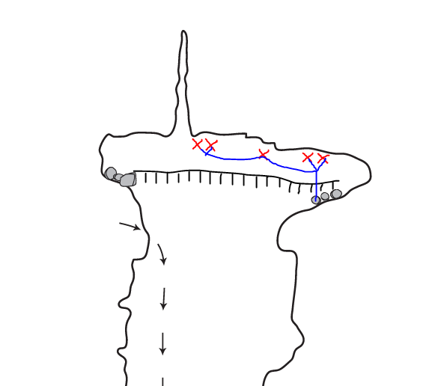

Hardware Specifications
- 5 bolts: 3/8” x 2 ¾” 316 SS wedge bolts

Rope Specifications
- 11mm nylon static kernmantle, unknown lengths, unknown manufacturer. May be two different rope sections joined at double bolt anchor on the south passage approach side

Hazards Identification
Hazard | Identified? | Notes/mitigation efforts
Rock/rope abrasion | Yes | Some wall contact when climbing up to the double bolts on the south approach side
Waterfall/rope abrasion | No | N/A
Abrasion from use | No | Low traffic area, especially if rope tail is tied back to discourage use
Rock fall | Yes | Lots of loose rock on ledge could dislodge and damage the Mt. Stromboli Dome fixed rope system below. Most concerning rocks were removed during rope installation
Moisture corrosion | Yes | All bolts are corrosion resistant 316 stainless steel. Nylon ropes lose about 15% of rated strength when wet, but are still within safe working load (SWL). Humid environment due to small waterfall nearby
Galvanic corrosion | No | Only stainless steel hardware used.
Age | Yes | Indefinite lifetime on hardware. 10 year maximum lifetime on nylon ropes per most manufacturers
Dynamic fall from user | Yes | Static ropes can be damaged from dynamic falls. Traverse line would experience this if a visitor fell while attached to it
Cave animals | No | Rope location is not reachable by animals known to chew on ropes, like pack rats or mice
Chemical exposure | No | No chemical exposures expected
Rock Decay | Yes | Mediocre rock quality for all bolts. Primary hazard that needs monitoring

Inspection Interval: 3 years
Low traffic is expected on this rope, but since the bolts are placed in mediocre dolomitic rock, a more frequent inspection interval is necessary to ensure that the recently installed bolts (August 2019) maintain their integrity. Therefore it is recommended that this fixed rope system should be inspected at the same time as the Mt. Stromboli Dome fixed rope: at least every 3 years, or anytime upon receiving any report of damage from a preserve visitor.

Repair/Replacement Considerations
Should any part of this fixed rope system need to be repaired or replaced, it can be approached via the ledge with caution. If the fixed rope system is deemed unsafe to use upon an initial inspection, while on belay with a dynamic line it could be repaired or derigged. In lieu of this, the rope should be tied back or cut in some manner as to make it unusable for visitors.

Southeastern Cave Conservancy (SCCi)
Permanent Fixed Ropes Inspection Report

Cave Name: __Gourdneck____

Location | Rope Install Date | Hardware Install Date | Designated Inspection Interval | Last Inspection Date | Rope Replacement Date | Hardware Replacement Date
Axel Falls bypass | 8/21/19 | 8/21/19 | 1 year | 5/31/2021 | 10/23/20 | N/A
Hans Falls | 12/3/17 | 12/3/17 | 1 year | 5/31/2021 | N/A | N/A
Halfway House Dome | August 2019 | 10/25/19 | 5 years | 5/31/2021 | N/A | N/A
Mt. Stromboli Dome | 7/14/19 | 7/14/19 | 3 years | 5/31/2021 | N/A | N/A
Mt. Stromboli Traverse line | 8/22/19 | 8/22/19 | 3 years | 9/19/2020 | N/A | N/A

Inspection Reports:
9/19/2020 – Quick inspection of all fixed ropes while on a survey trip in the cave. All appeared well.
10/23/2020 – Inspected Axel Falls bypass rope upon receiving a report from a preserve visitor that the rope was damaged. It was indeed damaged, the sheath in one spot was very rough and the rope was distinctly supple there. Could not identify a reason behind the rope damage. Replaced the rope with another similar short rope, no other changes.
05/31/2021 – Rigging trip to get the Halfway House Dome fixed rope system to match the specs listed in this document. It is now rigged with 9mm rope from one double bolt anchor at the top (177’). Also derigged a short fixed rope at the very end of the cave about Mt. Stromboli; removed two bolts and left one bolt/hanger for the pulldown. Inspected all other fixed ropes except the Mt. Stromboli traverse line during the trip and found no issues.
05/07/2022 – No issues seen on Axel and Hans Falls. Another qualified caver had inspected the other ropes in April and said they were also in good condition.

