Memorandum of Agreement
between
Southeastern Cave Conservancy, Inc.
and
William R. Gates (Wheeler National Wildlife Refuge)

The Southeastern Cave Conservancy, Inc. (SCCi) and William R. Gates on behalf of The Wheeler National Wildlife Refuge (Applicant) enter into an agreement to engage in a research project to determine the presence or absence of the fungus Geomyces destructans (Gd) on the SCCi Tumbling Rock Cave, Jackson County, Alabama property.

The scope of this research project includes collection of soil, guano, or wipe samples. It is anticipated that the samples will be archived until funding is received for analysis. The SCCi opines that the presence of Gd prior to the observed occurrence of White Nose Syndrome (WNS) in bats at the cave does not indicate mode of transport to or deposition in the cave (contrary to application statement by the Applicant).

The period of this agreement is from February 13, 2010 until December 31, 2010. The parties to this agreement recognize that this Memorandum of Agreement (MOA) may be renewed on an annual basis at the discretion of the SCCi and based on the needs and performance of the Applicant. However, the MOA becomes immediately void if the Applicant violates the terms and or conditions of this MOA or any non-excluded provisions of the management policy, as determined by the designated project representative of the SCCi.

Responsibilities of William R. Gates (Wheeler National Wildlife Refuge)
The Applicant agrees to follow the protocols outlined in its attached application and to abide by the following restrictions:

- No collection of live specimens is authorized for this project, except for microscopic organisms present in soil, guano, or wipe samples;
- Soil, guano, or wipe samples collected from the cave will not remain property of the SCCi nor will the samples be returned to the cave;
- Observe procedures outlined in Attachment A “Recommended Procedures to Prevent the Spread of White Nose Syndrome”, U.S. Fish and Wildlife Service, June 2009 (or most recent version);
- Provide a copy of all data and reports generated as part of this research project to the SCCi;
- Not enter the property unless a representative from the SCCi is present;
- Limit the total number of people entering the cave to 5, including the representative of the SCCi and up to four others;
- Work through the designated contact person from the SCCi
- Provide unrestricted use release for all reports; photographs remain the property of the photographer;
- Provide a written trip report of each entry before the next entry
- Abide by the terms and requirements outlined in the Project Application

(Attachment B), except as authorized by this MOA;
- Whatever else the Project (Special Uses) Committee, or SCCi Board, determines is necessary.

Responsibilities of the SCCi:
- designates Jay Clark as the contact person from the SCCi;
- The SCCi will provide reasonable access to the property as determined through the designated SCCi contact.

Attachments:
- A Disinfection Protocol
- B Project Application

Accepted By:

_________________________________ ________________
(SCCi chair) (Date)

_________________________________
(Applicant) (Date)

ATTACHMENT A

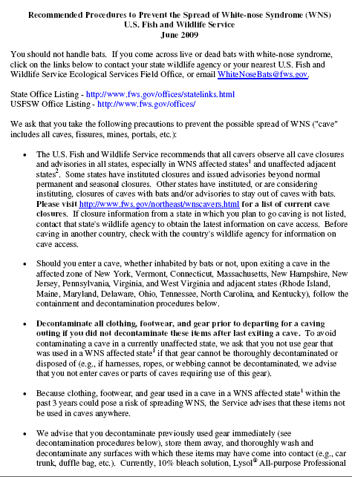
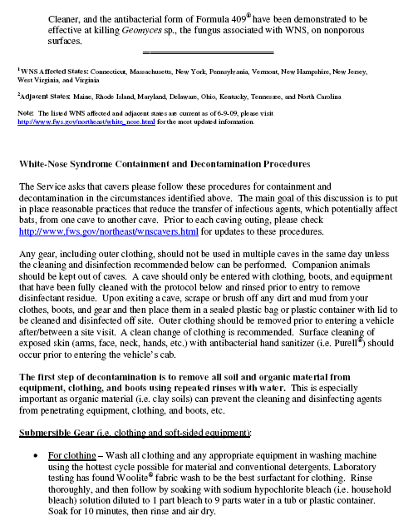

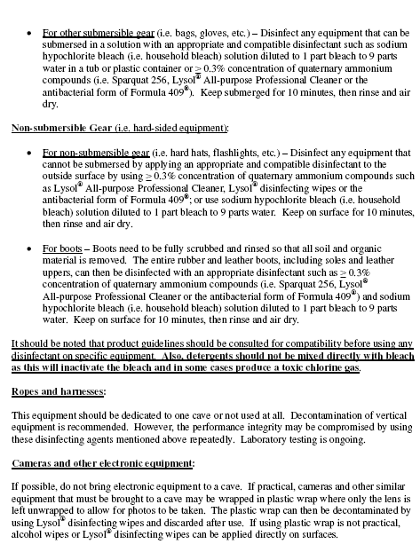

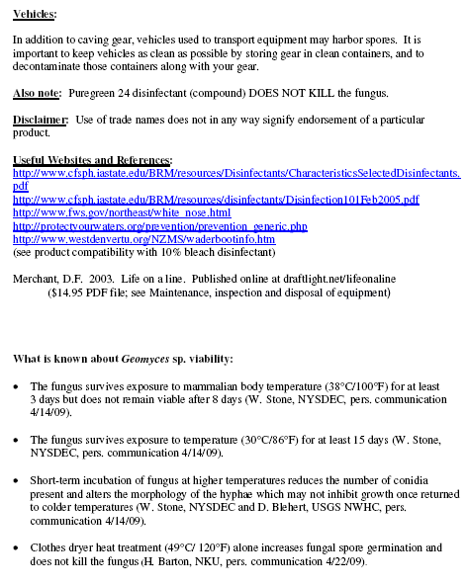

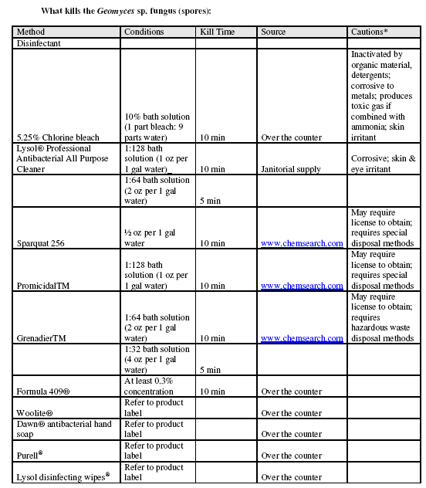

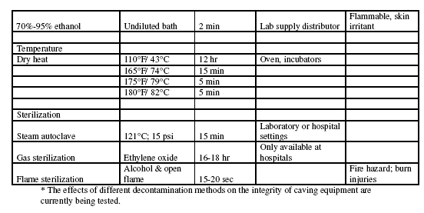

ATTACHMENT B

PROJECT APPLICATION

Application
For
Scientific Research or Special Use Project
on
SCCi Owned and/or Managed Properties
(Adopted – February 7, 2009)

SECTION I: Abstract or Summary
Please provide a brief summary of the project. Include purpose, anticipated goals, the start and end dates, techniques to be used, name of the cave or caves, or the properties, on which the exploration or study project will take place.

The purpose of this scientific study is to help understand if the White-nose Syndrome (WNS) fungus, Geomyces destructans (Gd), is spread by cavers. We plan to sample a few caves that have in the past or are currently used by a large number of cavers. Small amounts of soil and/or guano samples in areas typically used by cavers will be removed from approximately 5 sites in each cave at two different times- one prior to the arrival of WNS in the cave and one after arrival of WNS (assuming WNS will reach the cave). The samples will be checked for signs of Gd once monies become available for this lab work. If we find Gd in the samples taken prior to WNS arrival, this will provide some evidence that it was spread to the cave by people. If not found, this does not necessarily indicate Gd was not present in the cave. It just indicates it was not in the samples. Sampling will occur post arrival to determine if the sampling protocol will find Gd when present. In addition to the soil samples, 25 sites on the cave wall and other areas may be rubbed with moist cotton, such as a Q-tip (we do not endorse this product via its mention here). The cotton will be moistened with water. The sample will later be rubbed on a slide, perhaps after preservation (for example, after placement in ethanol), and the contents examined for the presence of Bd conidia (basically spores). The start date will likely be early in 2010 (January through March) and will end once samples can be obtained after the arrival of WNS. Obviously, the end date cannot be stated at this time. The caves are Tumbling Rock and the Surprise Pit.

SECTION II: Name of Project

Sampling of Caves for Signs of Human Spread of White-nose Syndrome

SECTION III: Applicant

Name of individual or organization

If an organization, the individual with overall responsibility for the project:

Name: William R. Gates/ Wheeler National Wildlife Refuge
Address: 2700 Refuge Headquarters Road, Decatur, AL 35603
Telephone: 256-353-7243 Extension 25
Fax: 256-340-9728
Email: William_Gates@fws.gov

SECTION IV: Individual Responsible for Performing the On-Site Project Operations

Name: Steve Pitts will be responsible but others may help.
Address:
Telephone: 256-603-6125 (cell)
Fax:

SECTION V: Financial Information
If the project is receiving funding of any kind, please attach a copy of the grant, contract, or other information relating to the amount of the funding, source of the funding, and duration of the funding.

The project does not have funding at this time. Volunteers will perform the sampling. Most supplies for sampling soil/guano were left over from a previous project of a very similar nature. Wheeler National Wildlife Refuge (WNWR) will provide materials for collection of the cotton swab samples from the cave walls, floors, and similar locations and for preservation of the samples. All samples will be stored at WNWR until funds become available for testing.

SECTION VI: Additional Information Related to the Project
Please provide the following information. If this material is contained in existing resumes or contracts then simply attach those documents.

Credentials of those conducting the project: Include information only on the individual responsible for the actual work. Include past studies conducted; expertise in the field in question; and educational qualifications.

Steve Pitts and Jennifer Pinkley or a similarly qualified caver will conduct the actual work in the caves. Their credentials:

Similar work gathering soil samples in Fern Cave (did not include the Surprise Pit entrance), at the request of William Gates/WNWR, in late 2008 or early 2009 for examination by the National Wildlife Health Center for Gd after training gathering samples in Sauta Cave that same year. No sampling experience using cotton swabbing of cave substrates. Steve Pitts has 30 years of caving experience and Jennifer Pinkley 25 years. Any other individuals entering with them (up to two) must have enough experience caving, utilizing appropriate gear, to safely enter the caves and who are known to respect cave resources. Individuals and gear used must meet the standards for not spreading WNS detailed in the decontamination guidelines on the Northeast U.S. Fish and Wildlife Service WNS website at the times the caves are sampled. Steve Pitts will make the decision if these individuals and the equipment meet these qualifications and standards.

A description of the methods to be used to execute the project goals: destructive or non-destructive methods, examples include: bolting; digging; other modification to the cave walls or passage; collecting samples, current or historic; photography; on-site examination; trapping and return of live samples; etc.; Studies that involve capturing and reintroducing live samples should provide proof that their live samples have historically successfully re-acclimated.

See the description of the project above. A rock with flagging or some type of small marker may have to be used at the five sites during initial sampling to insure they can be located for the second round of soil/guano sampling (that is, after the cave has been infected with WNS). Photographs of each site may be taken during initial sampling to insure location of the sampling sites after WNS infection of the cave.

A description of the data and the format in which it will be reported: what type of information will the project yield? Examples - Data, photographs, excavation and recovery of historic items, new passage? How and where will this be reported—in a paper for an institution of higher learning, a national journal or magazine, a specialty journal, only to the SCCi board?

Reporting of results may only be to the SCCi Board. However, it may also be reported in a scientific journal if one can be located that will publish it and also may be reported at WNS conferences, in related newsletters, and similar media. Photographs of sampling sites and related activities may be taken. Data will be in the form of dates, observers, general description of the sampling sites, a positive or negative indication of WNS discovery at each site sampled, and similar information.

Number of entries: the number of times the property or cave must be entered. The number of entries, and the proposed date for each, should be included.

Only two entries should be needed- one in early 2010 and the other after each cave is infected with WNS.
Duration of each event: how much time will be spent on SCCi properties during each entry?

Sampling sites must be scattered through each cave to insure each sample is independent of the others. Exact amount of time is not known but should not take longer than 10 hours.

Number of personnel involved: the number of persons it will take to conduct the project for each visit; and overall.

The minimum number needed to enter each cave for sampling is two to insure safety of any samplers. Up to two others may be involved to help with sampling.

The proposed schedule: when will the project begin, when will it end, when each of the site visits be made.

See the previous information.

